WIE MEET 2015

-HEMANGINI MALHOTRA, BVCOE

The WIE Affinity Group of BVPIEEE successfully organized the WIE meet 2015 on 14th March. The meet witnessed an overwhelming response with a turnout of more than 70 registrations from various Student Branches, even from outside Delhi defying the misconception of the meet meant only for women.

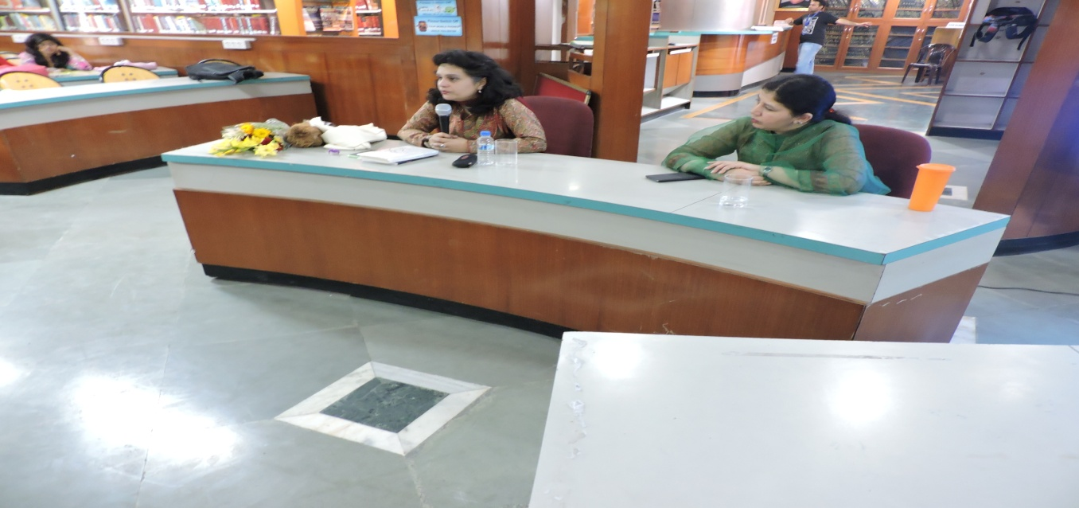

Ms. Rashmi Anand, our guest of honor, along with our Student Branch Counselor, Mrs. Yogita started the meet by highlighting the social issues faced by women of our country. It was followed by a healthy and interactive session suggesting the solutions and viewpoints of students from various Student Branches. Followed by a round of refreshments, a fun event named ‘Finding Namo’ took place wherein participants had to find people with associated things mentioned in the questions. To increase the interaction more between the student groups, another icebreaker event followed where students were divided in a team of five and worked their minds off for the brainstorming questions. All the events were taken with astonishingly high enthusiasm by the participants.

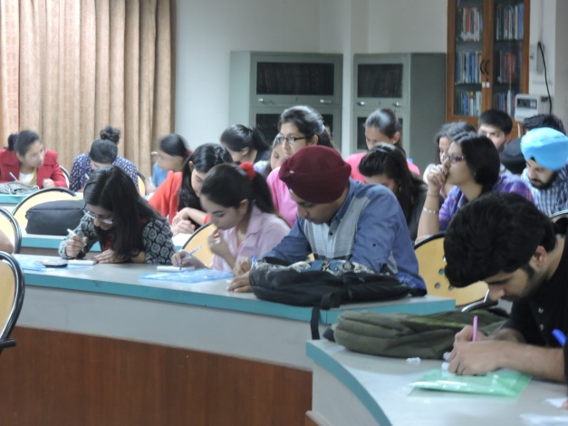

This was followed by introduction to the BVPIEEE team, all the SIG’s and chapters associated with it and WIE Affinity group accomplishments. There were presentations from other Student Branches as well.

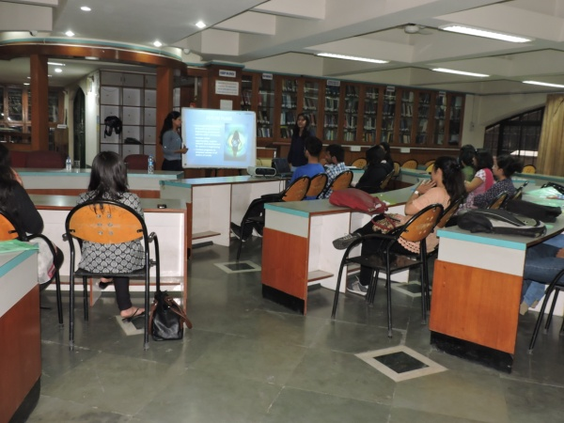

The event concluded with an informal discussion round highlighting various issues faced by different student branches during the running of WIE affinity groups or IEEE in general. A few of the problems discussed are as follows:

* Ways to increase technical activities in WIE
* Ways to spread awareness regarding WIE, and that men can and should be a part of WIE and its meets.
* Backup plans in case of technical glitches faced in Student Branch Competitions.